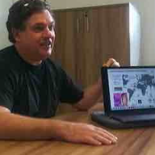
Professor Paul W. Denny
Professor in Biosciences Department
University of Durham, United Kingdom
p.w.denny@durham.ac.uk
Professor Paul W. Denny is a professor in the Department of Biosciences at Durham University, United Kingdom. Before this appointment (2004), Prof. Paul was employed in post-doctoral associate and research fellow posts with Prof Debbie Smith at Imperial College London, where he developed research interests in the molecular and cellular biology of lipid biosynthesis in the kinetoplastid protozoan parasites, particularly Leishmania spp. Now, with colleagues at Durham, Prof. Paul is focused on the characterisation of protozoan sphingolipid biosynthesis and the identification of novel antimicrobial targets within both the Kinetoplastidae and the Apicomplexa. He is the founding director of the Durham Centre for Global Infectious Disease (CGID), Principal Investigator and director of the Durham Global Network for Neglected Tropical Disease (MRC GCRF) and theme lead for the Molecular Sciences for Medicine (MoSMed) EPSRC Centre for Doctoral Training (Newcastle and Durham). Several examples of Paul’s work on inhibitors of Leishmania sphingolipid biosynthesis have recently been published. Furthermore, he has also been extensively involved in -omics projects designed to elucidate new antileishmanial drug targets.

